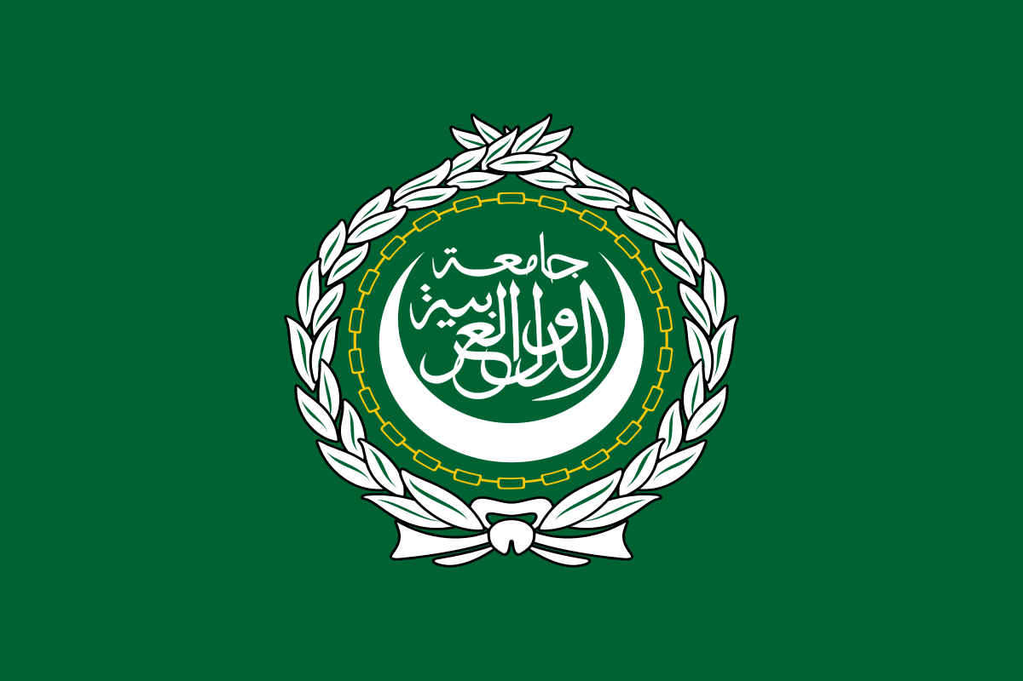
BACKGROUND GUIDE

ARAB LEAGUE

Qatar Diplomatic Crisis

Letter from the Executive Board

Greetings Delegates,

We welcome you to the simulation of the Arab League here at Utopia Model United Nations 2018 . We shall be discussing the theme “The Qatar Diplomacy Crisis” for the purposes of this simulation.
This committee will be based on a crisis and consequent updates which you will be receiving from the Executive Board from time to time. The committee will mainly be focused upon debating and deliberating handling the situations that arise in a manner which would be in the best interest of this organization and it’s members. As delegates, you will be expected to be thorough with your research and base your analysis and conclusions on the same during debate. Please remember, a Council is only as strong as its individual delegates, and that the Executive Board is here merely to guide debate, not to take part in it.

Note: This background guide is only for the purpose of Assistance with regards to better study of the procedure and the agenda. Nothing stated in the background Guide can be used as evidence in the council or as citation
You may feel free to contact the Executive Board in case you have any doubts regarding procedure or the functioning of the committee.

Best of Luck!

Arjun Dev Chopra (Secretary General- chopra06315@gmail.com)
Raahul Sharma (Deputy Secretary General- simyvin@gmail.com)
Aryaman Ray (Director- aryaman.ray11@gmail.com)

How to go about Crisis Committees:

Committees such as these require a high level of spontaneity and immense amounts of detail due to the significance of the effects of any action taken by the council. We expect all the delegates representing different portfolios to be well versed with their respective duties in the committee. In committees such as these all updates are linked together and have some end result which is what the committee is going to be moving towards. Taking into consideration this linkage amongst the information, you will be supplied through various updates. We recommend you to analyses the various causes and effects and encourage you to hypothesize and take actions accordingly. The best way to do these committees is through an amalgamation of Logic and Research.

Procedure:

This committee will not be following the exact UNA-USA rules of procedure.
To ensure free flow of debate we wish to have a procedure as simple as possible so that there is better facilitation of debate. The nature of debate would be less formal than other conventional UN committees.
We as the Executive Board have thought of a brief procedure for the committee which however, can be amended by the committee as a whole if need be.

- Roll Call
- Round Robin session (for opening statements)
- Moderated Caucus (for the discussion of detailed topics)
- Unmoderated Caucus (for drafting plan of actions and deciding the further course of debate)
- Discussion of Plan of Actions on the table

- Point of Orders - In committees such as this, accurately verifying the facts is very difficult so we would be ruling upon points of orders in very selective cases, primarily those where there is actual documented proof. Delegates are requested not to raise frivolous point of orders on events which are not well documented and do not have factual backing.

* The delegates are to note that we would be encouraging Questions to speeches, the number of which will be decided by the Executive Board.

* Any Procedural doubts will be taken up by the Executive Board at all points of time.

Overview about the Agenda:
It all started on May 23 when an alleged fake news report run by a Qatari news agency stated Qatar’s support for Iran and a U.S designated terror group from Palestine, Hamas. This was the tipping point for decade long tensions between Doha and its neighboring countries to simmer over.
The news report released statements by Qatar’s Emir Sheikh Tamim bin Hamad Al Thani. In these statements, which Qatar maintains are false, the Emir called Hamas ‘the legitimate representative of the Palestinian people” and said that the country shares “strong relations” with Iran, a region archrival of Sunni-majority Saudi Arabia.
The report was widely publicized in other Arab countries despite Qatar reiterating that it was fake and that the Emir never spoke the statements attributed to him.
Meanwhile, the leaked emails of the Emirati envoy in Washington seem to show his country s long-running desire to counter Qatari influence.
These two events triggered what we now know as the Gulf crisis: On 9th June, nine countries cut off diplomatic ties with the tiny but rich state of Qatar. These nations include three members of GCC (Gulf Cooperation Council), Bahrain, UAE and Saudi Arabia. The rest of the countries are Egypt, the Maldives, Mauritania, Yemen and the U.N.backed government of Libya. Four additional countries – Djibouti, Jordan, Senegal and Chad – have downgraded their ties with Qatar.
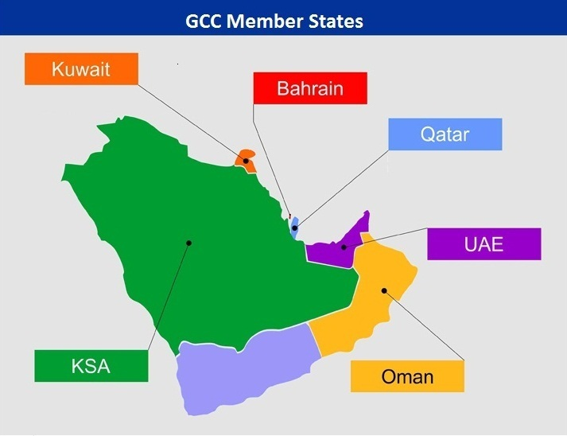
Qatar’s foreign policy has always been rather different than that of the rest of the Gulf States. While Bahrain largely follows Saudi Arabia’s foreign policy, Qatar has diverged from other members of the GCC. After the Arab Spring, Qatar aligned itself with Islamist political parties such as Egypt’s Muslim Brotherhood which has been declared as a terrorist group by Saudi Arabia and United States. Qatar’s state funded news network Al Jazeera also seems to support these groups as champions of democracy. Qatar was also amongst the most active backers of Islamist fighters in rebellions in Syria and Libya. This coupled with the fact that Qatar enjoys close ties with Tehran, has bothered the Saudi led bloc.
Egypt also considers the Brotherhood to be dangerous. During the 2011 Arab Spring, Qatar backed the Brotherhood and the protestors against the then-President Hosni Mubarak. It supported Morsi, Egypt’s first democratically elected leader and a member of the Brotherhood. This stands in stark contrast with Riyadh whose support was for Mubarak and currently backs President Abdel Fateh el-Sisi , a former military leader. Qatar’s news agency Al Jazeera has been widely criticized of supporting the Brotherhood during the Arab Spring. Several Al Jazeera journalists were detained in Egypt for supporting Mohammed Morsi.
Qatar has also been accused of backing Yemen’s Houthi rebels which is a startling claim given that Qatar, until the day before the crisis, was part of the Saudi-led coalition fighting the Houthi rebels, who are allegedly backed by Iran and ex-President Saleh.
Middle Eastern expert Hassan Hassan explains that the countries of the region can be divided into two camps: “one that seeks to advance its foreign interests through support of Islamists, and one whose foreign policy is guided by opposition to the rise of Islamists.” Qatar falls into the first category while the Saudis and Emiratis fall into the second category.
Several Arab countries have accused Qatar of sponsoring terrorism, including al Qaeda’s Syrian affiliate Nusra Front, Afghan terror group Taliban, and Hamas. However, even Saudi Arabia has been accused of financing Nusra Front.
President Donald Trump’s recent visit to Riyadh also seems to have emboldened Saudi officials. On Tuesday after the crisis, Trump tweeted about Qatar, linking it to funding of radical ideology.
Doha shares good diplomatic ties with Iran. The ownership of South Pars/North Dome Gas Condensate field, the world’s largest natural gas field, is shared by Iran and Qatar which unites the countries in wealth. Qatar became the world’s largest exporter of liquefied natural gas (LNG) owing to the shared gas field. Doha has struggled to maintain good relations with the GCC and Iran simultaneously.
The crisis shows deep rooted and complex divisions in the Middle East which the west often tries to downplay by portraying it as nothing more than tensions between Saudi-led Sunni bloc and Iran led Shiite bloc.
There seems to be no easy solution to the crisis in the foreseeable future. The crisis could lead to food and water shortages in the country because of the blockade imposed by its neighbors. Doha has called this a “collective punishment”. Intermarriages between Qataris and nationals of other GCC countries have resulted in families being torn apart because of Qatari citizens being ordered to leave Saudi Arabia, Bahrain and UAE within 14 days. Qatar’s air travel came to a halt after the Gulf neighbors decided not to fly their airlines to Qatar. Qatar was forced to suspend its flights to the countries that imposed the blockade.
It’s hard to gauge what happens next. Oman and Kuwait, the remaining GCC countries not involved in the crisis, may try to exert what limited power they have to reach a compromise between the four Gulf States caught up in the crisis. The United States may intervene as well considering that Qatar hosts the largest US military base in the Middle East though Trump’s series of tweets seems to go against the instincts of the American foreign policy. Qatar has significant fiscal reserves, enjoys good relations and political support of Erdogan and Turkey and is a key energy partner for Russia and China. Saudi Arabia and Emiratis may soon realize that cutting off ties and attempting to isolate Qatar is not as easy as they thought.
Expectations from the council:
This committee will not be simulated like a conventional United Nations committee. Inside this committee all members would be working in one single direction which is in the best interest of the Muslim Brotherhood and the Arab world. However this does not mean that there can’t be differing opinions. Debating is all about addressing differences of opinion. However all of us here would have a common interest which would be to work towards the best interest of this committee and the country in question.

In unconventional committees like this we expect you to think out of bounds and take steps that are not possible in the normal conventional committees.

We expect the council to work as one cohesive unit and achieve the required objective at hand and take necessary steps for the same.

Important Links for Research:
1)https://www.huffingtonpost.com/entry/the-gcc-qatar-crisis-explained-all-you-need-to-know_us_5947b9ece4b024b7e0df4daf
2) https://www.bbc.com/news/world-middle-east-40173757
3) https://www.haaretz.com/middle-east-news/iran-could-be-winner-us-a-loser-from-uae-qatar-tensions-1.5792025
4) https://www.aljazeera.com/indepth/features/2017/06/qatar-gulf-crisis-questions-answered-170606103033599.html
5) https://www.vox.com/world/2017/6/6/15739606/saudi-arabia-ties-qatar-trump

